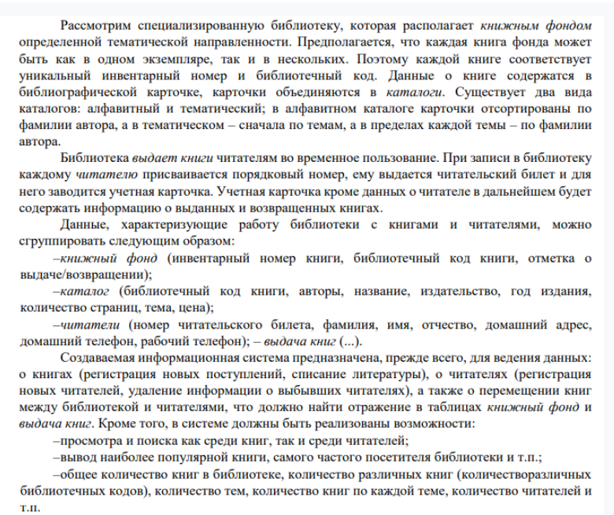

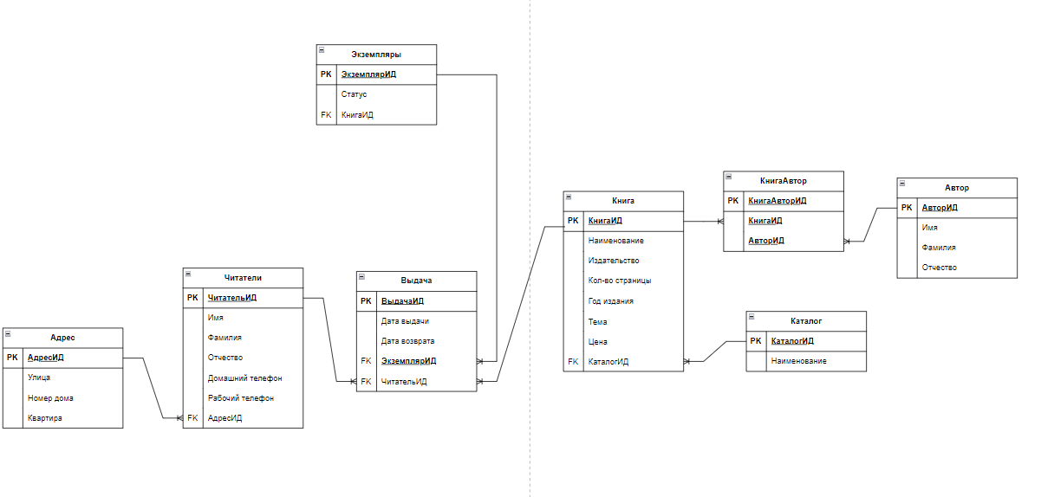

|  |
| --- |
| **CREATE** **TABLE** Address (  AddressID SERIAL **PRIMARY** **KEY**,  Street **VARCHAR**(100),  HouseNumber **VARCHAR**(10),  Apartment **VARCHAR**(10)  );  **CREATE** **TABLE** Readers (  ReaderID SERIAL **PRIMARY** **KEY**,  FirstName **VARCHAR**(50),  LastName **VARCHAR**(50),  MiddleName **VARCHAR**(50),  HomePhone **VARCHAR**(15),  WorkPhone **VARCHAR**(15),  AddressID **INT** **REFERENCES** Address(AddressID) **ON** **DELETE** **SET** **NULL**  );  **CREATE** **TABLE** **Catalog** (  CatalogID SERIAL **PRIMARY** **KEY**,  **Name** **VARCHAR**(100) **UNIQUE**  );  **CREATE** **TABLE** Books (  BookID SERIAL **PRIMARY** **KEY**,  Title **VARCHAR**(255),  Publisher **VARCHAR**(100),  PageCount **INT**,  YearPublished **INT**,  Topic **VARCHAR**(100),  Price **DECIMAL**(10,2),  CatalogID **INT** **REFERENCES** **Catalog**(CatalogID) **ON** **DELETE** **SET** **NULL**  );  **CREATE** **TABLE** Authors (  AuthorID SERIAL **PRIMARY** **KEY**,  FirstName **VARCHAR**(50),  LastName **VARCHAR**(50),  MiddleName **VARCHAR**(50)  );  **CREATE** **TABLE** BookAuthors (  BookAuthorID SERIAL **PRIMARY** **KEY**,  BookID **INT** **REFERENCES** Books(BookID) **ON** **DELETE** **CASCADE**,  AuthorID **INT** **REFERENCES** Authors(AuthorID) **ON** **DELETE** **CASCADE**  );  **CREATE** **TABLE** Copies (  CopyID SERIAL **PRIMARY** **KEY**,  Status **VARCHAR**(50) **CHECK** (Status **IN** (**'В наличии'**, **'Выдана'**, **'Списана'**)),  BookID **INT** **REFERENCES** Books(BookID) **ON** **DELETE** **CASCADE**  );  **CREATE** **TABLE** Borrowings (  BorrowingID SERIAL **PRIMARY** **KEY**,  IssueDate **DATE** **NOT** **NULL** **DEFAULT** **CURRENT_DATE**,  ReturnDate **DATE**,  CopyID **INT** **REFERENCES** Copies(CopyID) **ON** **DELETE** **CASCADE**,  ReaderID **INT** **REFERENCES** Readers(ReaderID) **ON** **DELETE** **CASCADE**  ); |